User Guide - Team 2

UMGC CMSC 495 Section 7381

Blumenshine, Tyler (Member 1)

Eckart, Timothy (Member 2)

Gordon, Ricardo (Member 3)

Mclaughlin, Mitch (Member 4)

Patel, Siddharth (Member 5)

Table of Contents:

Introduction ………………………………………………………………………………………2

Overview of the software …………………………………………………………………………2

Purpose of the User Guide ………………………………………………………………………..2

Target audience …………………………………………………………………………………...3

Getting Started ……………………………………………………………………………………3

Installation instructions …………………………………………………………………………...3

System requirements ……………………………………………………………………………...8

User interface overview …………………………………………………………………………..9

Using the Software ………………………………………………………………………………..9

Step-by-step instructions for using the software's main features ………………………………..11

Troubleshooting tips ……………………..……………………………………………………...22

Reference ………………………………………………………………………………………..27

Glossary of terms ………………………………………………………………………………..28

Weekly Contribution …………………………………………………………………………….29

**Introduction**

Welcome to the user guide for the Low Earth Orbit (LEO) Satellite Simulation application. This interactive JavaFX-based program was developed to simulate the natural orbital decay of satellites due to atmospheric drag. It allows users to input key parameters, such as mass, altitude, velocity, and ballistic coefficient, to visualize orbital motion and receive real-time calculations, including orbital period, total number of orbits, and estimated re-entry time. Whether you're a student, researcher, or enthusiast, this guide will walk you through installing, operating, and understanding the core features of the simulation.

**Overview of the software**

The Low Earth Orbit (LEO) Satellite Simulation is an interactive JavaFX application that models the natural orbital decay of satellites due to atmospheric drag. Users can input parameters such as satellite mass, altitude, velocity, and ballistic drag coefficient to visualize orbital motion and receive calculations for orbital period, the number of orbits over a lifecycle, and re-entry timeframe. It provides a visual and educational interface for exploring real-world orbital mechanics through physics-based simulations.

**Purpose of the User Guide**

This guide is intended to help users install, operate, and understand the key features of the LEO simulation software. It also includes troubleshooting advice and reference materials to help resolve common issues and understand the technical terms used within the application.

**Target audience**

This guide is designed for students, researchers, and enthusiasts in aerospace engineering, software development, or physics who are interested in orbital mechanics and satellite behavior. A basic familiarity with Java applications and physics principles will enhance the user's experience, but it is not required.

**Getting Started**

Before running the application, ensure your development environment is configured correctly:

**Installation instructions**

*\*PLEASE REFERENCE README FILE FOR MANUAL DOWNLOAD & INSTALLATION\**

**User Installation Instructions**

**Required Files**

**Ensure you have the following files:**

* manifest.txt
* LEOSatelliteSimulator-1.0-SNAPSHOT.jar

**Step 1: Install PostgreSQL and pgAdmin**

**Download and install PostgreSQL and pgAdmin based on your OS:**

* PostgreSQL: [Download Here](https://www.postgresql.org/download/)
* pgAdmin: [Download Here](https://www.pgadmin.org/download/)

**Step 2: Create the Database**

**Open pgAdmin and run the following SQL code in the Query Tool:**

**Standard Database Creation:**

*CREATE DATABASE "SatelliteSimulator"*

*WITH OWNER = postgres*

*ENCODING = 'UTF8'*

*LC_COLLATE = 'en-US'*

*LC_CTYPE = 'en-US'*

*LOCALE_PROVIDER = 'libc'*

*TABLESPACE = pg_default*

*CONNECTION LIMIT = -1*

*IS_TEMPLATE = False;*

**Alternative for Other OS Users:**

*CREATE DATABASE "SatelliteSimulator"*

*WITH OWNER = postgres*

*ENCODING = 'UTF8'*

*LOCALE_PROVIDER = 'libc'*

*TABLESPACE = pg_default*

*CONNECTION LIMIT = -1*

*IS_TEMPLATE = False;*

**Step 3: Create the Tables**

**Satellite Table:**

*CREATE TABLE IF NOT EXISTS public."Satellite" (*

*"Satellite_ID" serial PRIMARY KEY,*

*"SatelliteName" text COLLATE pg_catalog."default",*

*"User_ID" bigint,*

*"Mass" numeric(10,4),*

*"Altitude" numeric(10,4),*

*"Speed" numeric(10,4),*

*"Area" numeric(10,4)*

*) TABLESPACE pg_default;*

*ALTER TABLE public."Satellite" OWNER TO postgres;*

**Users Table:**

*CREATE TABLE IF NOT EXISTS public."Users" (*

*"USER_ID" serial PRIMARY KEY,*

*"Name" text COLLATE pg_catalog."default" NOT NULL,*

*"Email" text COLLATE pg_catalog."default" NOT NULL,*

*"Password" text COLLATE pg_catalog."default" NOT NULL*

*) TABLESPACE pg_default;*

*ALTER TABLE public."Users" OWNER TO postgres;*

**Step 4: Add a Database User**

**Run the following SQL commands to create a new database user:**

*CREATE USER Satellite_User WITH PASSWORD '123456789';*

*GRANT USAGE, SELECT ON SEQUENCE "Satellite_Satellite_ID_seq" TO Satellite_User;*

*GRANT CONNECT ON DATABASE "SatelliteSimulator" TO Satellite_User;*

*GRANT USAGE ON SCHEMA public TO Satellite_User;*

*GRANT SELECT, INSERT, UPDATE, DELETE ON ALL TABLES IN SCHEMA public TO Satellite_User;*

*ALTER DEFAULT PRIVILEGES IN SCHEMA public*

*GRANT SELECT, INSERT, UPDATE, DELETE ON TABLES TO Satellite_User;*

**Step 5: Enable Encryption**

**Run this command to enable pgcrypto for password encryption:**

*CREATE EXTENSION pgcrypto;*

**Step 6: Insert a Default User**

**Run the following SQL command to insert a default user with an encrypted password:**

*INSERT INTO "Users" ("Name", "Email", "Password")*

*VALUES ('Default_User', 'nowhere@mail', crypt('sfhot45822nRFe3554?#$d', gen_salt('bf')));*

**Step 7: Verify User Table**

**To check if users were added successfully, run:**

*SELECT * FROM "Users";*

**Step 8: Run the Application**

**Open Command Prompt and execute the following command:**

*java --module-path "C:\Program Files\openjfx-24_windows-x64_bin-sdk\javafx-sdk-24\lib" --add-modules javafx.controls,javafx.fxml -jar LEOSatelliteSimulator-1.0-SNAPSHOT.jar*

**Where "C:\Program Files\openjfx-24_windows-x64_bin-sdk\javafx-sdk-24\lib" is the location of your JavaFX lib folder.**

**System requirements**

1. Display:- Minimum: 1080p resolution.
   1. Recommended: 1440p or higher for a more straightforward graphical interface.
2. Peripherals:- External mouse and keyboard for precision (helpful for testing and running the simulation).
   1. Optional: Multiple monitors for enhanced multitasking.
3. JavaFX Dependencies:- Ensure compatibility with JavaFX SDK 17+ and JDK 17+ on all platforms.
   1. Include a compatible JDBC driver for database integration.
4. Cooling and Reliability:- Simulations can be CPU/GPU-intensive, so a workstation with adequate cooling and a stable power supply is essential.

**Recommended hardware configuration**

| **Component** | **Windows** | **MacOS** | **Linux** |
| --- | --- | --- | --- |
| **Processor** | Intel Core i7 (3.0 GHz) or AMD Ryzen 7 | Apple M2 or Intel Core i7 | AMD Ryzen 7 or Intel Core i7 |
| **Ram** | 16 GB | 16 GB | 16 GB |
| **Storage** | 512 GB SSD (or larger) | 512 GB SSD (or larger) | 512 GB SSD (or larger) |
| **Graphics** | Dedicated GPU (e.g., NVIDIA GTX 1660 or AMD RX 560) | Apple M2 GPU or AMD GPU | NVIDIA GTX 1660 or AMD RX 560 |
| **Operating System** | Windows 11 | macOS 13 (Ventura) or newer | Ubuntu 22.04 (or Fedora 37) |

**User interface overview**

* Log-In Window: Allows users to log in using their email and password
* Input Screen: Allows users to enter satellite parameters (name, mass, area, altitude)
* Simulation Screen: Displays a rotating 3D Earth and animated satellites in real-time. Outputs are displayed here: orbital period, lifecycle orbit count, and re-entry estimates.
* UI Tab: Allows users to input additional satellites and view data such as speed, orbital period, re-entry time, and more.
* Navigation Buttons: Include options to calculate, reset, add new satellites, or exit the simulation.
* Export Button: Allows users to create an Excel data sheet report for all the satellite data in the database.

**Using the Software**

**Log in and Create a New Satellite**

1. Log in Using your User Name and Password.
2. Select the New Satellite Button
3. Input Name, Mass, Area, and Altitude
4. Hit the Submit Button
5. The simulation will now show a satellite orbiting the Earth.

**Viewing Satellite Data and Adding Additional Satellites**

1. Select the UI Tab.
2. The satellite data will be on the left side of the window.
3. Select the New Satellite Button
4. Input Name, Mass, Area, and Altitude
5. Hit the Submit Button
6. A new satellite will be added to the left panel.

**Export Data**

1. Select the UI tab after creating a new satellite for the first time.
2. Click the export satellite data button.
3. Save the Excel file in your desired location.
4. View the Excel file.

**Step-by-step instructions for using the software's main features**

**Step 1:** Log in

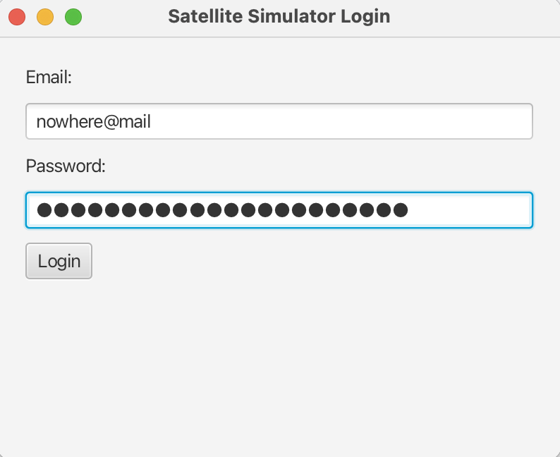

**Step 2:** Click **New Satellite** Button

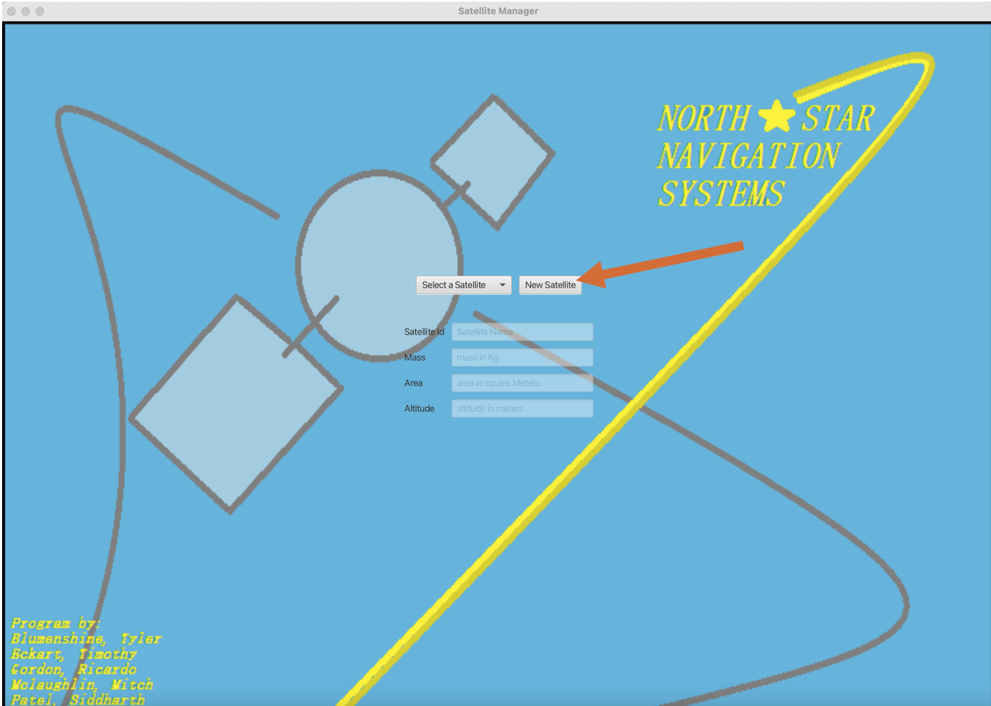

**Step 3:** Enter values: **Satellite ID** (i.e., name), **Mass**, **Area**, & **Altitude**

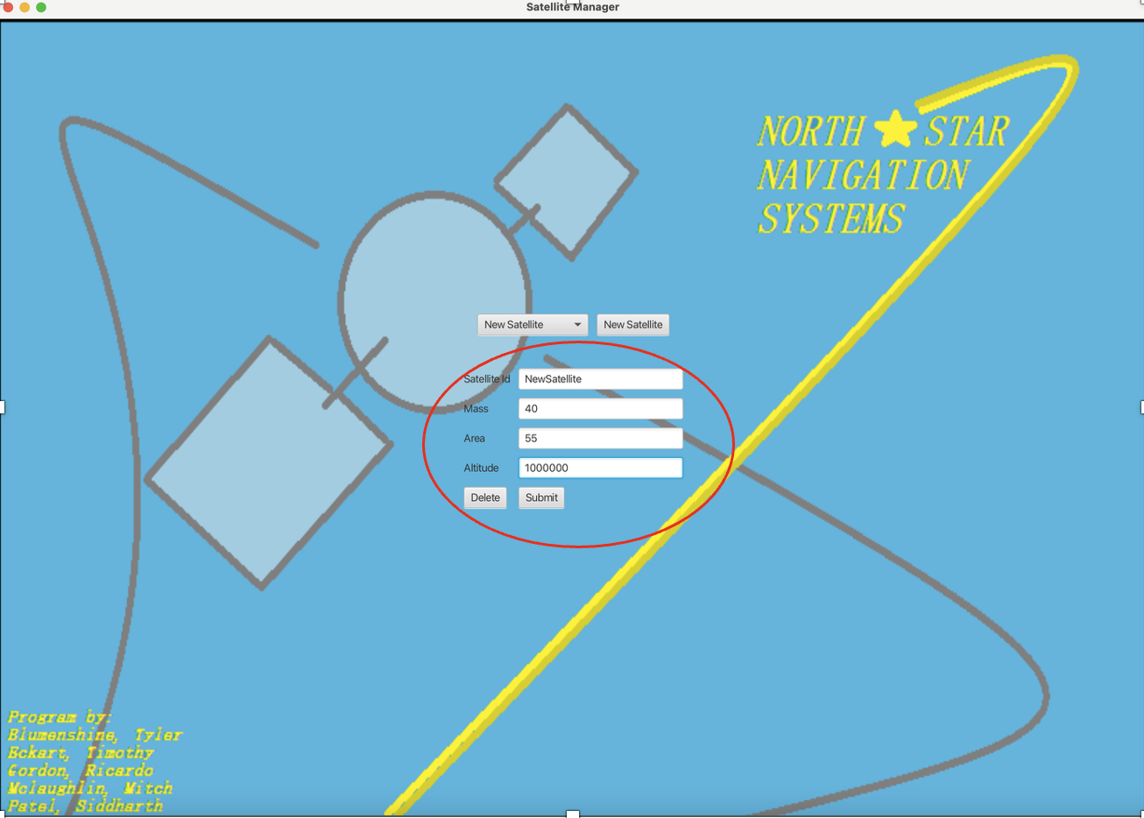

**Step 4:** Click **Submit** 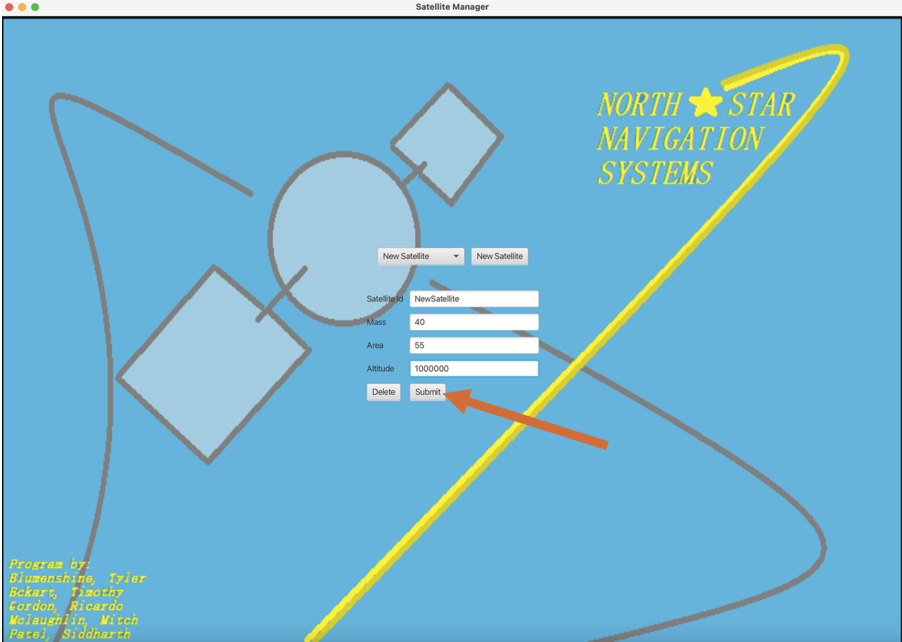

**Step 5:** Examine Simulation Results

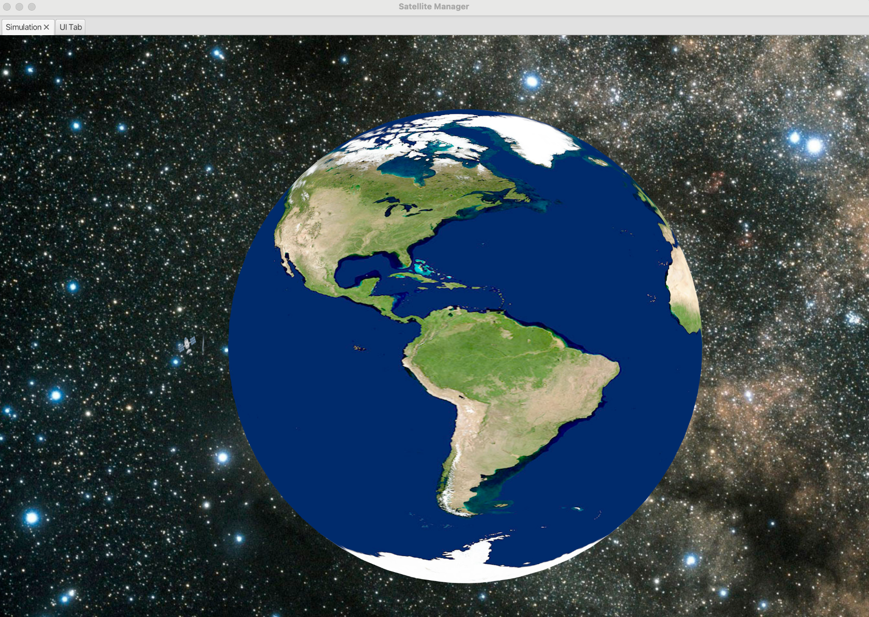

**Step 6:** Click the **UI Tab** for Calculation Results

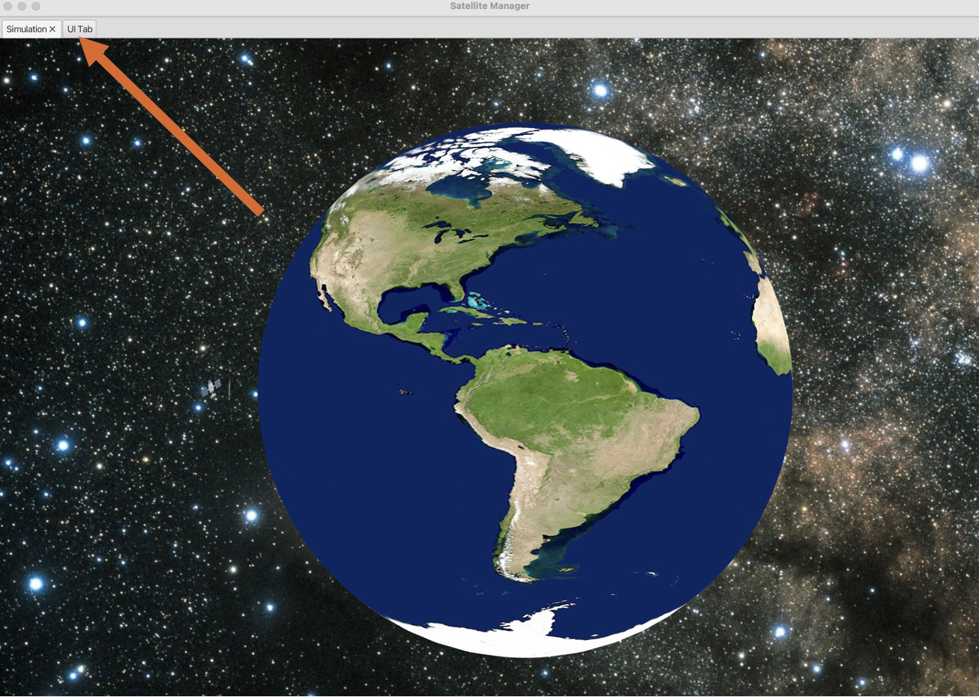

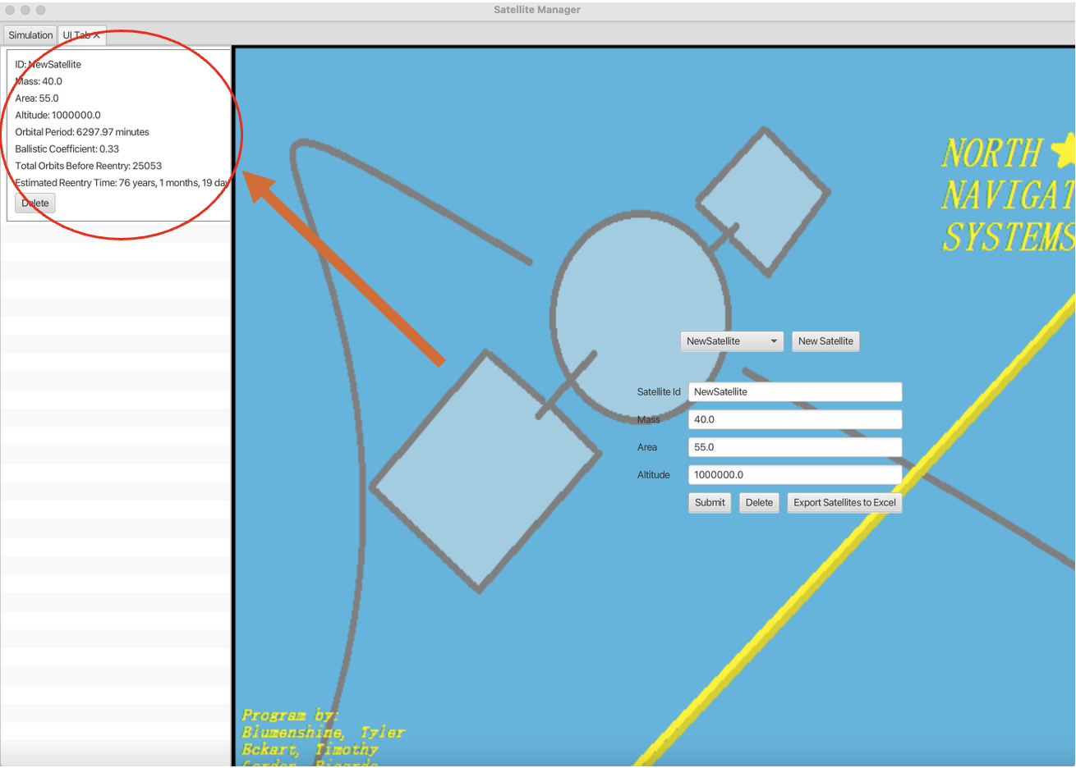

**Step 7: (**Optional)Enter New Values & Click **Submit**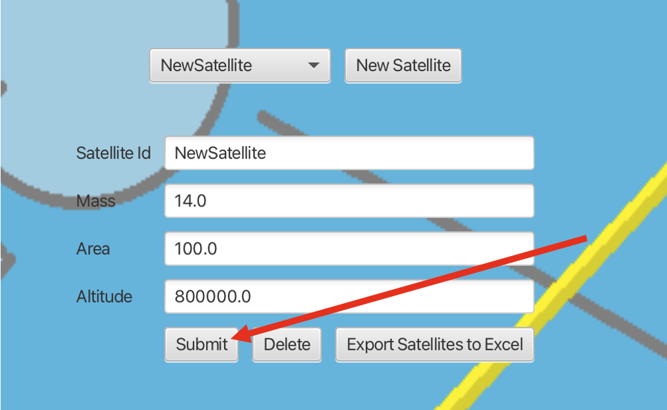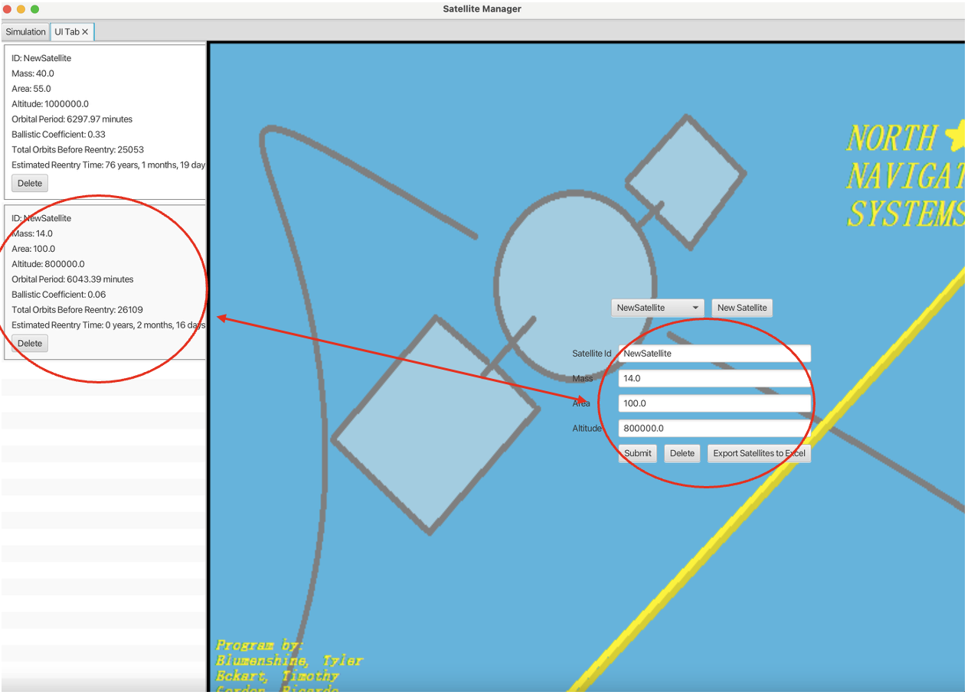

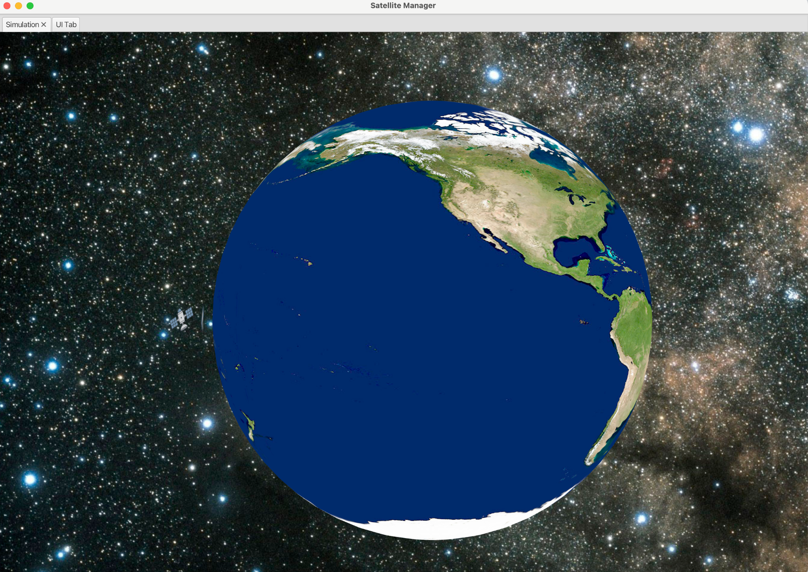

* **Note:** You can use the same Satellite ID (i.e., name) or create a new one

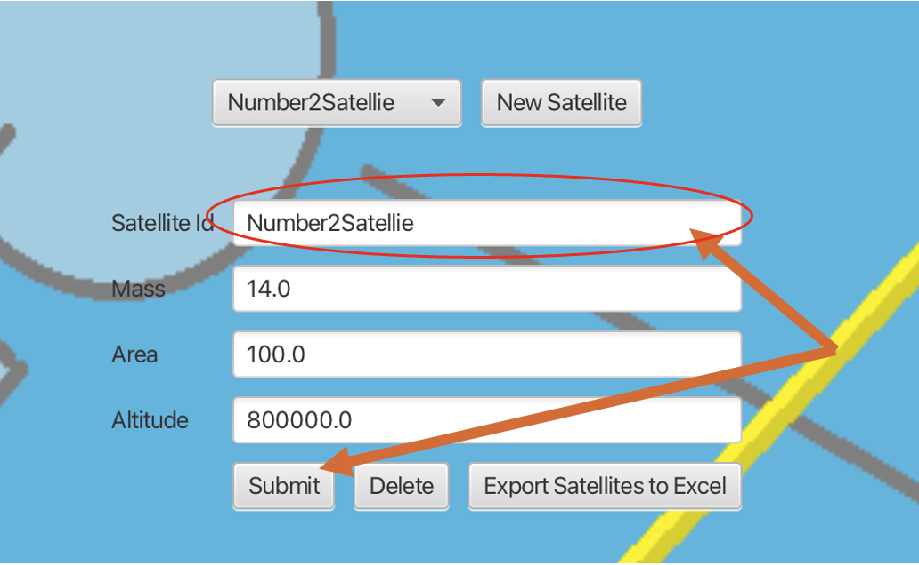

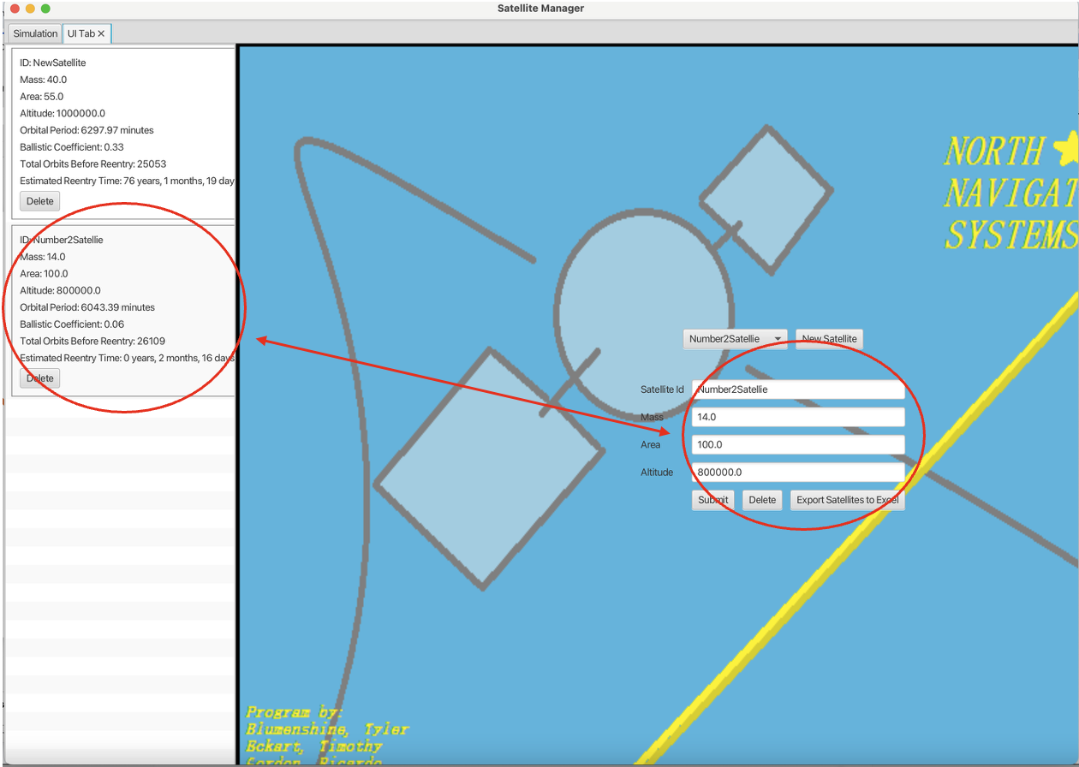

**Step 8:** (Optional) Click the drop-down to see previous **Satellite IDs**

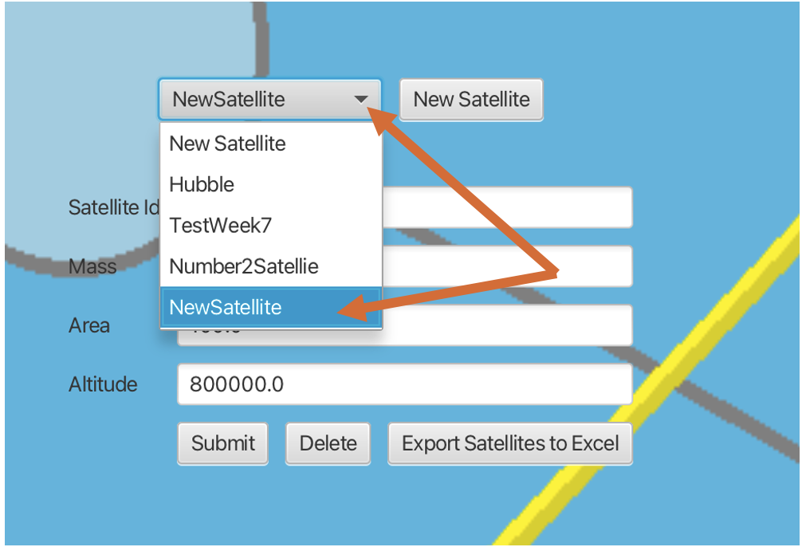

* Click **Submit**

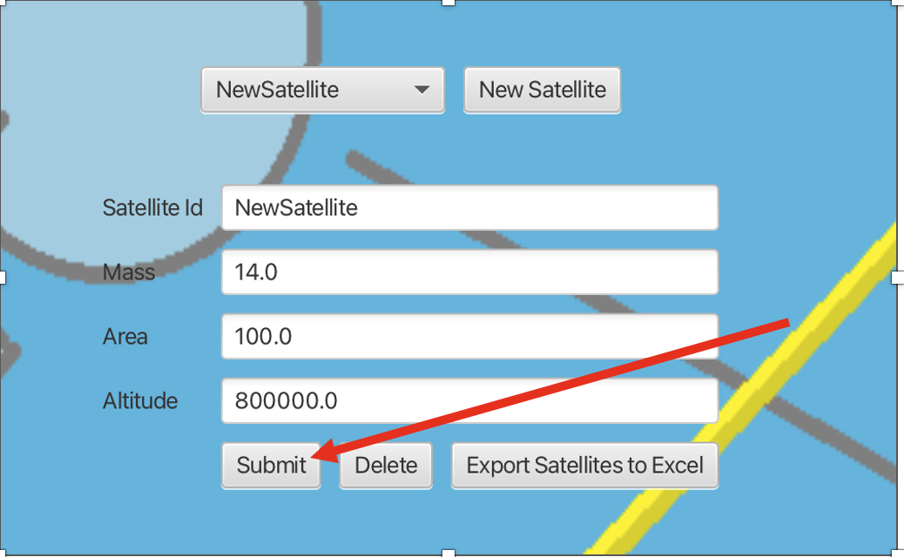

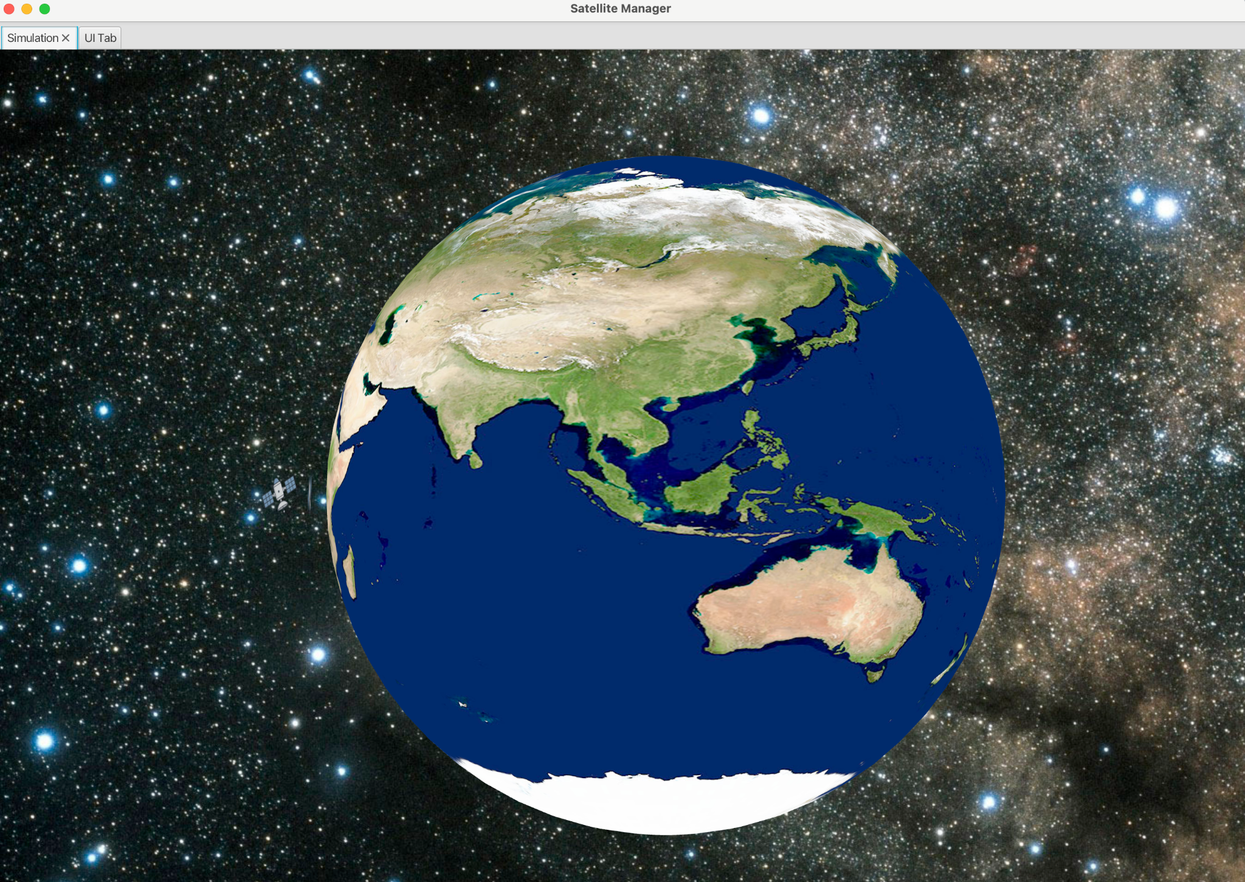

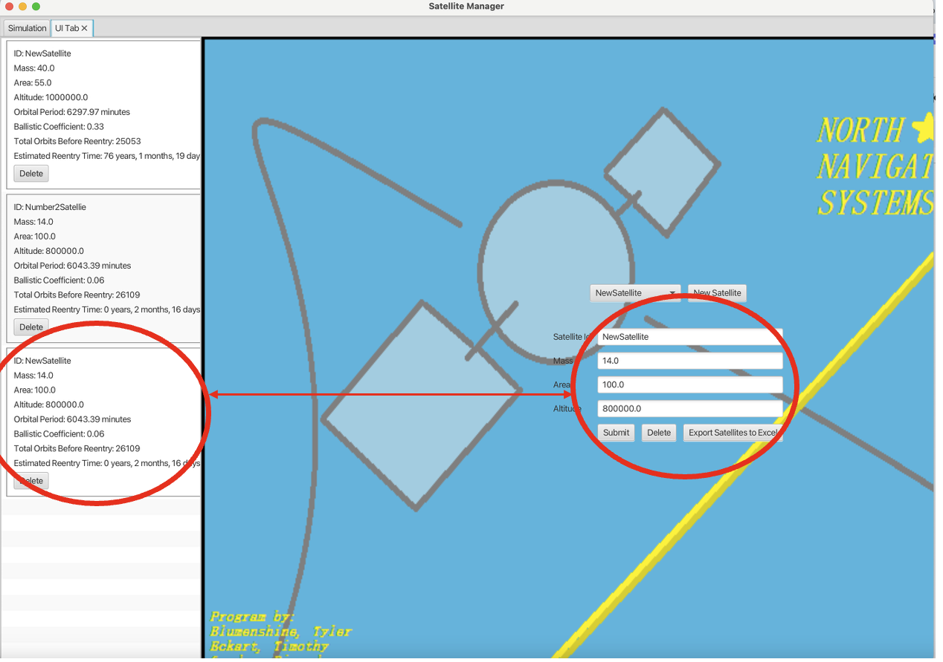

**Step 9:** Click **Export Satellites to Excel** to download and save your satellite data on an Excel sheet

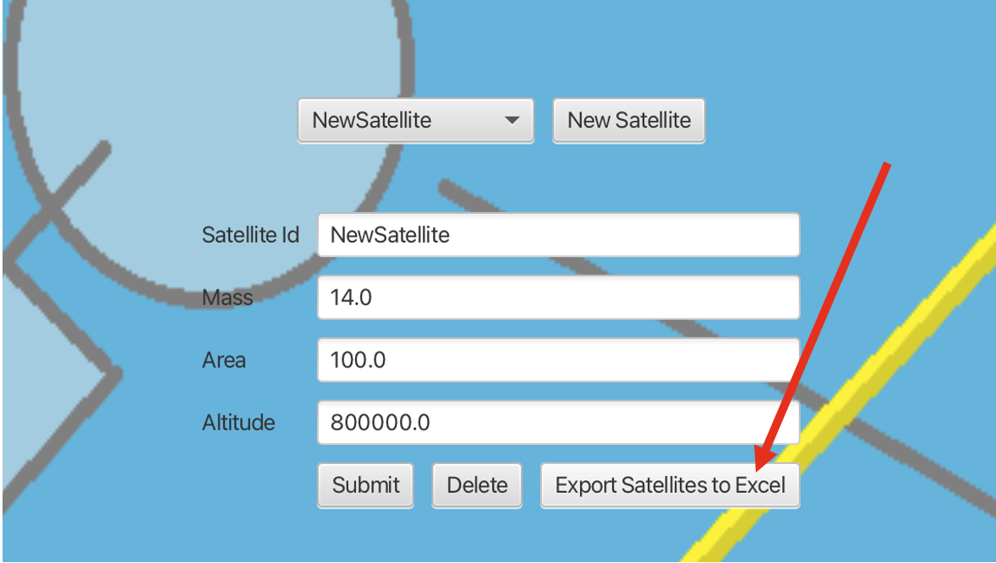

* Save to your desired Desktop location.

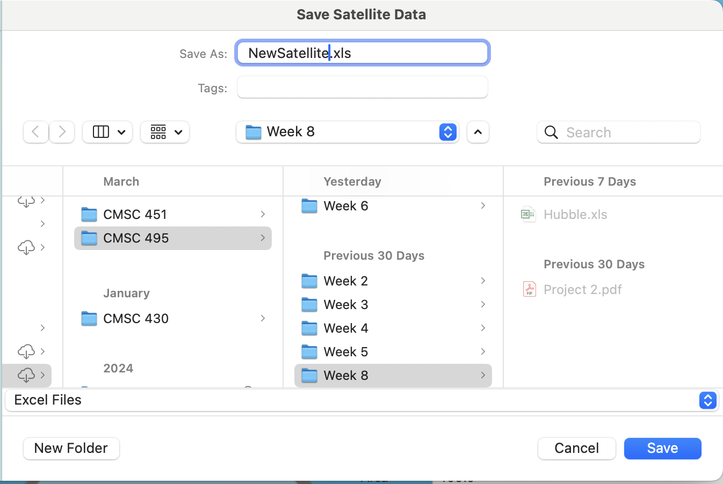

* Open Excel file

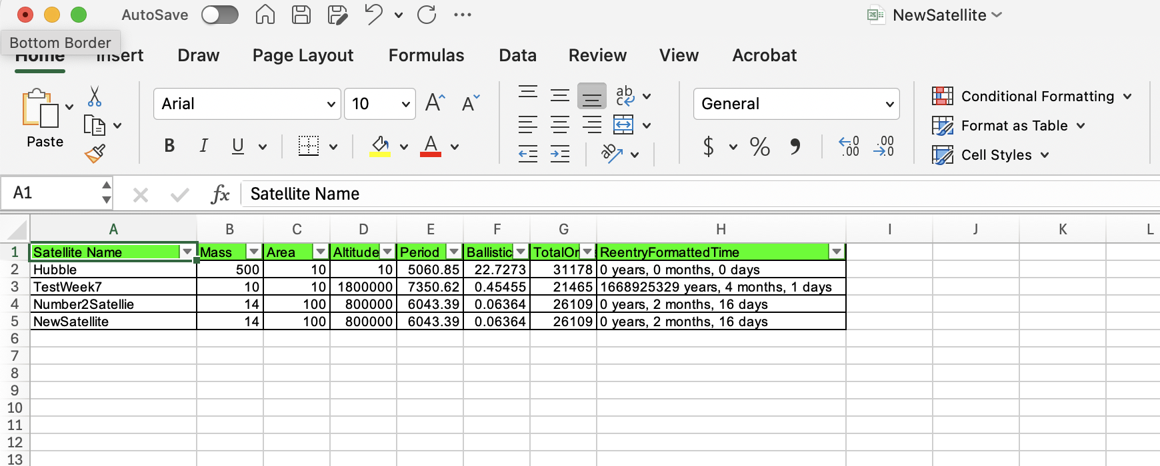

**Step 10**: (Optional) Click **Delete** to remove any Satellites from database.

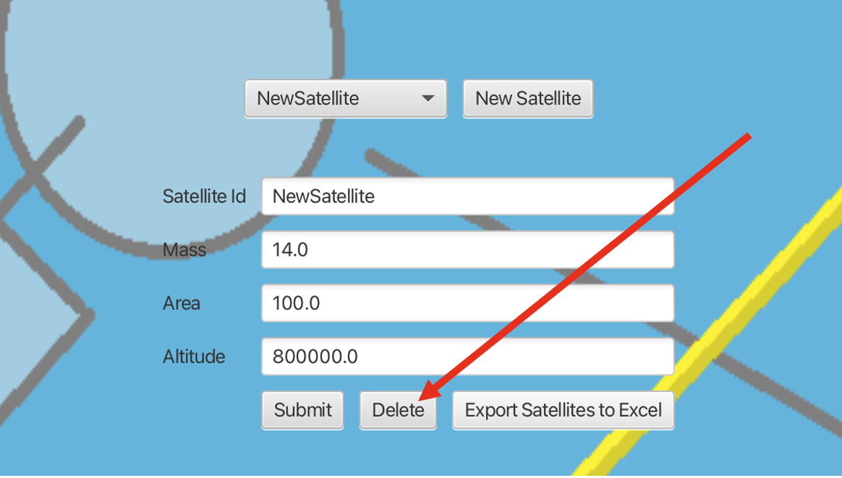

* Select **Yes**

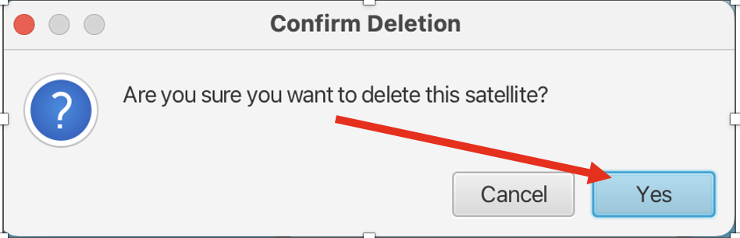

* **Note**: Stored Satellite will be removed

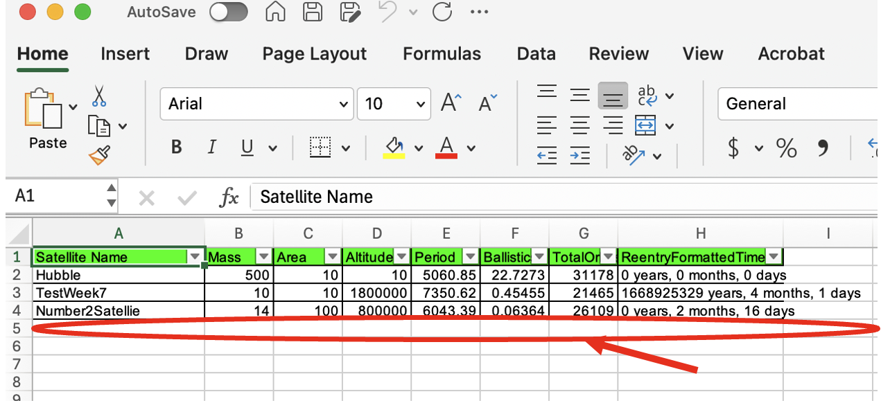

**Troubleshooting tips**

* ***The program files are unresponsive when I run the application…***

Ensure that the following external library plug-ins are downloaded and visible in the classpath build configurations, and also listed as dependencies for your run configurations: JBCrypt, JDK 21 or newer, PostgreSQL, and the JDBC driver. *See system requirements section above for further details for downloads and installations*

* **I cannot log in to the application on the first page…**

For added security of user logins, the developer team has decided to use the JBCrypt plugin for encrypted password hashing and hidden password typing. Further functionality to add custom username and password logins will be added at a later date. However, as of the program's launch, please refer to the default user login information in the “README” for all users. It can also be found below for your convenience:

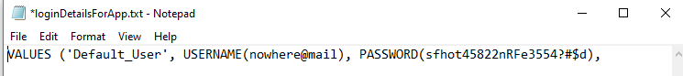

* ***My program is executing, but displaying Java errors…***

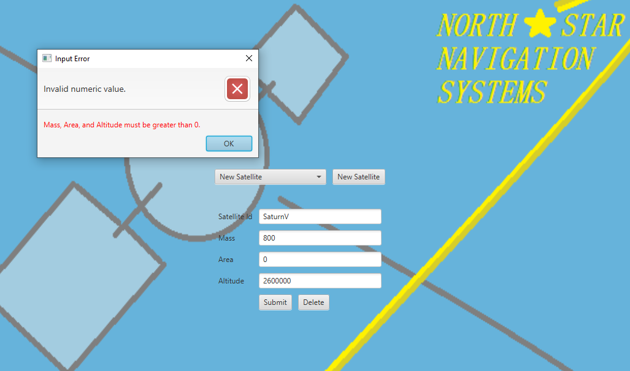

Due to the extensive error handling in this program, this normally means that there has been invalid user input in one of the User Interface tab’s text fields. Ensure that all inputs are positive in number, are numerical only in nature, and are less than a value of two million for the “altitude” input field. This program is a low Earth orbit satellite calculator and simulation. As such, an altitude higher than this value would be inaccurate at best.

* **An error when selecting an existing satellite from the drop-down box & submitting...**

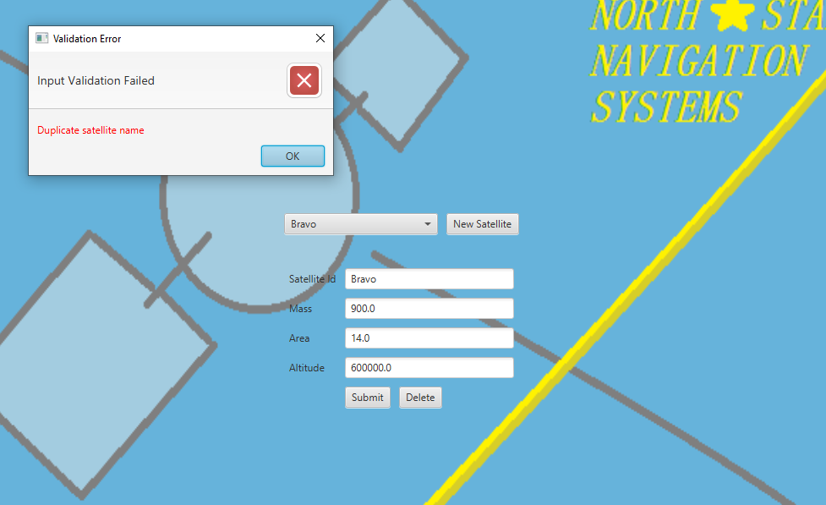

For the scope of this program, the ability to add satellites to the database and reference them later is just that: a reference. This allows you, as the use,r to directly pull up all of the inputs from a saved satellite you created. Still, you will need to change the name of the satellite again (re-instantiate the satellite object) before clicking the Calculate button, as two satellites with the same name cannot exist in the database.

* **My simulation tab is malformed, or some textures have not loaded in correctly…**

This means there is a problem with the program being unable to view the needed texture image files in your individual machine’s file system. The list of needed texture files included in the program files is as follows in the image below:

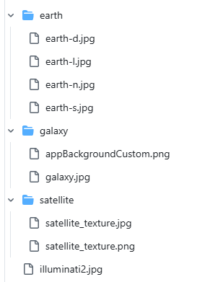

These files will need to be made accessible in your system, and the changes will occur in the Earth.java, satellite.java, and UserInterface.java Java classes, respectively. There are two ways of verifying a correct resource path for these images: a relative path and an absolute path. Our program’s bundled zip file naturally comes with the *relative path* for you, but you may want to use an absolute path if you continue to encounter problems with scope. You can alter the absolute path, the user (in the three Java files mentioned above), using this example layout for each image section:

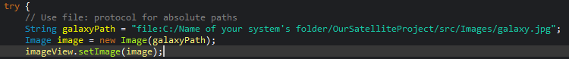

* **I am having issues with the dropdown box not showing any created satellites…**

This means you are having an issue with the database integration. Confirm that SQLite, PostgreSQL, and JDBC drivers are configured and not blocked by firewalls, and that they are included in the aforementioned classpath build configurations and dependency run configurations. The second troubleshooting step you may want to try is to ensure that in the DatabaseConnection Java file, you have the correct port number aligned with the port you assigned during your original installation of pgAdmin. The numbered port that most operating systems use is “localhost:5432”, but this may be different if you changed it. The file and line where you can edit your database port and login details to the database can be seen below in the DatabaseConnection Java class file:



**Limitations Of Application (version 1.0.0 effective april 29th 2025)**

The limitations of this Low Earth Orbit satellite calculator and simulation are as follows:

* This project currently only simulates and calculates low Earth orbit, equatorial, circular orbits with an eccentricity factor of 0; therefore, apogees, perigees, and Earth’s zonal harmonics are also null factors for calculation (Though this may change with future updates).
* This project only accounts for LEO satellites beneath the Van Allen radiation belt at 2,000 Km above the earth’s surface; as such, the Solar Radiation Pressure variable is at a packaged default of “slightly higher than normal sun” multiplier of 2.0 for sun activity, but can be altered in the AtmosphericDrag.java class to an even higher multiplier for sun flare situations or to fractional values for relatively inactive sun periods.
* This project assumes that J2 perturbation is negligible at the equator with an inclination of 0, as atmospheric drag is the primary factor in orbital decay.
* This project assumes no space collisions by the satellite's bodies occur during orbit, also known as Kessler syndrome, and assumes no after-thruster burns to send satellites into graveyard orbit or to prolong the retrograde timeframe back to Earth.
* The drag coefficient used when calculating ballistic coefficients is generally between 1.5 and 2.5; when combined and averaged for all geometric drag surfaces a satellite body can have. The most widely used globally is 2.2, and as such, this program uses that default in combination with the directional area you provide.

**References**

ESA. (2020, March 30). *Types of orbits*. The European Space Agency. https://www.esa.int/Enabling_Support/Space_Transportation/Types_of_orbits#PO

Roberts, T. G. (2022, June 14). *Popular orbits 101*. Aerospace Security. https://aerospace.csis.org/aerospace101/earth-orbit-101/#:~:text=The%20majority%20of%20satellites%20orbiting%20the%20Earth,at%20altitudes%20between%20160%20and%202%2C000%20kilometers.&text=Medium%20Earth%20Orbit%20(MEO)%20Although%20over%2090,for%20a%20smaller%20subset%20of%20satellite%20systems.

Majid, A., Owais, M. N., & Qureshi, M. N. (2018, July 1). Aerodynamic drag computation of Lower Earth Orbit (LEO) Satellites. https://www.ist.edu.pk/downloads/jst/previous-issues/july-2018/12.-aerodynamic-drag-computation-of-lower-earth-orbit-(leo)-satellites.pdf

NASA. (2025, April 29). *NRLMSIS 00*. NASA. https://ccmc.gsfc.nasa.gov/models/NRLMSIS~00/

NRLMSISE-00 empirical model of the atmosphere. (2025, April 29). https://map.nrl.navy.mil/map/pub/nrl/NRLMSIS/NRLMSISE-00/NRLMSISE-00_jgra16630.pdf

University Of Central Florida. (2016, August 3). *13.4 Satellite Orbits and Energy*. University Physics Volume 1. https://pressbooks.online.ucf.edu/osuniversityphysics/chapter/13-4-satellite-orbits-and-energy/#:~:text=To%20find%20the%20period%20of,with%20MSun%20in%20Figure.

And a special mention to the following reference for the simulation design:

*Afsalashyana - Overview*. GitHub. (n.d.). https://github.com/afsalashyana

#### **Glossary of Terms**

* LEO (Low Earth Orbit): An orbit within 2,000 km above Earth’s surface.
* Orbital Period: The time a satellite takes to complete one orbit around the entire Earth
* Ballistic Coefficient: A value representing a satellite’s ability to overcome atmospheric drag.
* Retrograde Timeframe: The estimated time before a satellite re-enters the Earth’s atmosphere.
* Jira: A project management tool used for issue tracking and scheduling tasks.
* JUnit: A testing framework for Java used to validate class-level functionality.
* JavaFX: A softwar**e platform for creating graphical user interfaces and simulations.**

**Weekly Contribution Report -**

Each team member played a key role in drafting and organizing the User Guide and refining the project source code for our JavaFX-based Low Earth Orbit (LEO) Satellite Simulator. The document was structured to prioritize user accessibility, clarity, and ease of use. Below is a summary of contributions for this reporting period:

* Tyler Blumenshine – Authored the Introduction, Overview of the Software, Purpose of the User Guide, Target Audience, and the Index/Table of Contents. He also coordinated the User Guide’s overall structure to ensure consistent tone and navigation throughout.
* Ricardo Gordon – Developed the Installation Instructions and System Requirements sections of the User Guide. In addition, Ricardo enhanced the project’s source code by adding a new feature that allows users to export their satellite database to an Excel file, improving data management options.
* Siddharth Patel – Wrote the User Interface Overview and the Using the Software sections, providing clear and concise explanations of the software’s interactive components.
* Timothy Eckart – Provided the Step-by-Step Instructions for Using the Software’s Main Features in the User Guide. Additionally, Tim consolidated all finalized code updates from the team and published the integrated version to the main branch on GitHub, ensuring consistency across the repository.
* Mitch McLaughlin – Contributed the Troubleshooting Tips and Limitations sections, offering users guidance for resolving common issues and highlighting known software constraints. He also compiled the Reference section.